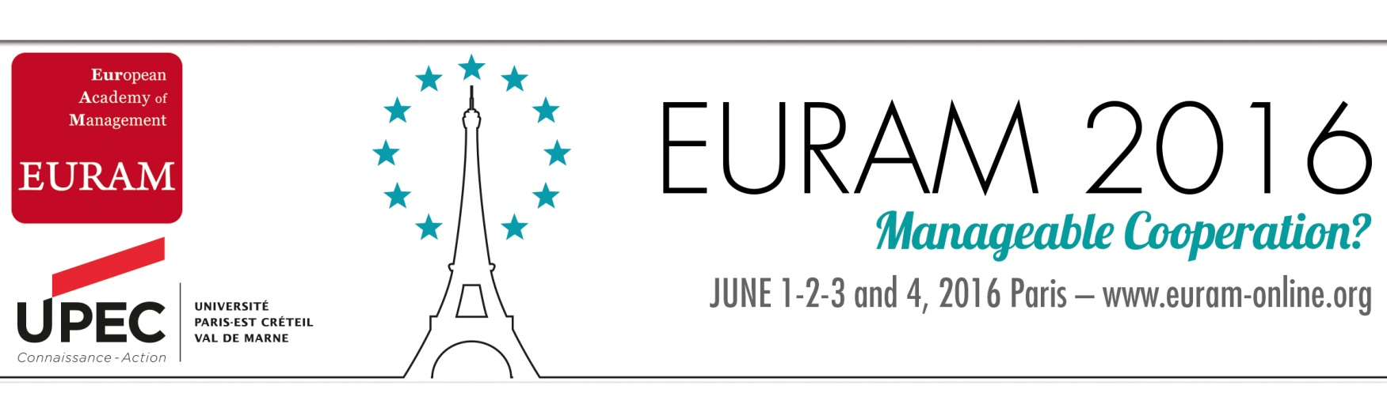

SIG: Business FOR Society

Track: Finance, Economy and Society, For a Sustainable Re-embedding

The financial crisis of 2008 and its aftermath have highlighted the limits and risks of an increasingly global and embedded economy. The social tumults and economic upheavals resulting from the subprime crisis have revealed the dysfunctioning, shortcomings and failures of the financial and regulatory institutions. Financialization has led to commodification, speculation and instability leading to moral hazard and causing disturbance in the real sector of the economy as witnessed by procyclical and countercyclical economic variables. In acknowledging the need for greater transparency and efficacy, researchers and practitioners have looked for alternative economic and financing models that challenge the capitalistic system of production and distribution.

The ‘Finance, Economy and Society: for a Sustainable re-embedding’ track invites the authors to submit their theoretical and empirical contributions with a focus on, but not limited to, the following questions and themes:

- How alternative sources of financing (e.g. microfinance, crowdfunding, cooperative banks, SME stock exchanges, SRI funds, faith-based financing) should be used to create more efficient and manageable cooperative schemes among different stakeholders?

- Can alternative sources of financing, notably microfinance or crowdfunding, create durable relationship between social actors and lead to social innovation? In which ways mutual and cooperative banks can support alternative business models congruent with long term societal goals?

- Are new and alternative sources of financing models symptomatic of or conducive to social innovation and new economic models in an emerging cooperative and collaborative economic environment?

- What other alternative economic models can be envisaged by those who operate at the bottom of the social pyramid? Can alternative market organizations formed by producer and consumer networks using other forms of currencies help social ties?

- How should the global financial system be regulated? How should economic and financial institutions co-evolve, co-operate, and co-construct mutually beneficial initiatives?

- How can different stakeholders (i.e. social entrepreneurs, firms, investors, consumers, employees) be brought to engage in mutually beneficial and rewarding relationship by creating shared value, and by being more engaging, ethical and innovative?

- What are the impact of regulations (Basle / Solvency) on organizational changes after an M&A, on banks and insurance companies’ governance, on inter-group liquidity risk management, on solvency risk and systemic risk management and on risk credit management and bank-counterpart relationship management (sovereign and corporate)?

- How can we begin to think differently about the regulatory setting in which business contributes to the wellbeing of society through tax payments, in the face of growing pressure to pay a fair share of tax coupled with increasing competition between nations to capture that share?

Catherine Karyotis, Neoma Business School, France
Sharam Alijani, Neoma Business School, France
William Sun, Leeds Beckett University, United Kingdom
Joseph Onochie, Baruch College, United States of America
Karima Bouaiss, School of Management Poitiers University, France

Deadline for paper submission: 12 January 2016

